DISCUSSION

In this thesis I explored how natural and altered environmental conditions shape the ecology of riparian plant communities. In this final chapter I aim to summarise the contribution of my thesis to the greater body of riparian plant ecology and river restoration research, outline outstanding questions raised by my work, and present some possible avenues for future work.

*Biogeographic context*

(Mason et al. 2013)The riparian plant communities described here were located primarily along coastally drained, mid-catchment rivers in partially constrained valley settings, spanning temperate and subtropical south-eastern Australia. A map showing field sites surveyed in Chapters 2-4 is shown below (Fig. 1). Although no systematic review has summarised ecological knowledge of Australian riparian plant communities, more research attention appears to have been focused on semi-arid, inland-draining systems such as the Murray Darling Basin, or larger tropical rivers, than these smaller coastal systems.

Additionally, much of the canonical riparian plant ecology literature was written about alluvial river systems in Europe and North America (Nilsson et al. 1989; Naiman and Decamps 1997; Tabacchi et al. 1998; Naiman et al. 2005; Corenblit et al. 2007). Flow regimes in south-eastern Australia diverge considerably from this canon: the seasonal regularity which characterises nival European and North American rivers is often replaced by substantial year-on-year variability (Finlayson and McMahon 1988; Peel et al. 2004). South-eastern Australian plants do exhibit characteristic species-level responses to seasonality, although there is no general coordination of growth and reproduction phenologies as in the Northern Hemisphere (Ford, Paton & Forde, 1979). As such, Australian riparian plant communities are likely to be adapted to different environmental controls. In common with North American systems, however, the signature of rapid landscape modification has been etched deeply into fluvial landscapes. Many rivers have undergone irreversible state transitions following European settlement (Knopf et al. 1988; Fleischner 1994; Wasson 1994; Brierley et al. 1999), and the mid-20th century saw the rise of extensive flow impoundment schemes in both continents (Lloyd et al. 2004; Graf 2006).

TONE THINGS DOWN A BIT, MAKE SURE IT ISN’T CONTROVERSIAL OR WANKY

This body of work therefore contributes some fresh perspective to the global literature, from species pools subject to a different evolutionary history and operating under different environmental conditions to the most commonly described riparian ecosystems.

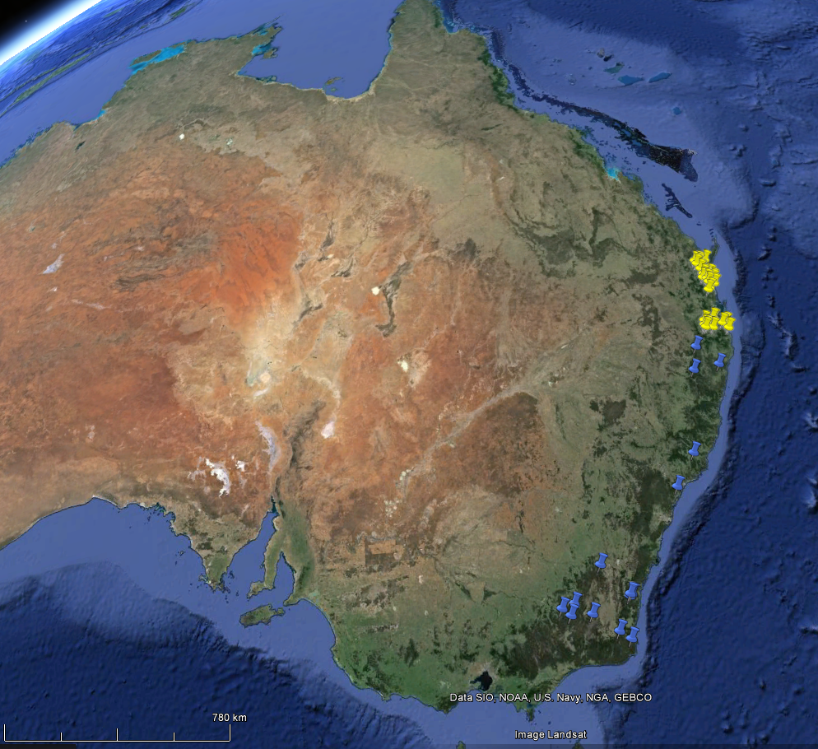

Figure 1. Map showing geographical distribution of field sites from Chapters 2 & 3 (blue) and 4 (yellow) (Google Maps 2015).

*Ecological responses of riparian plant communities to fluvial hydrology*

The relationship between environmental heterogeneity and biodiversity has been a key concern of ecologists since the early 1960’s (MacArthur and MacArthur 1961; Stein et al. 2014). Riparian landscapes provide particularly useful model systems for exploring hypotheses about environmental heterogeneity due to strong control of biotic assemblages by fluvial hydrology, and in tandem with disturbance, hydrologically driven environmental heterogeneity has taken a central role in our conceptualisation of how riparian ecosystems function (Poff et al. 1997; Naiman et al. 2005).

Chapters 2, 3 and 4 tested hypotheses derived from this paradigm. Broadly, my work confirms the importance of hydrological heterogeneity and fluvial disturbance in shaping riparian plant assemblages. The specific contribution of these chapters to the riparian literature lies in our mechanistic, functional trait based approach. Through the lens of functional traits, we have begun to address questions about how flow regime influences ecological strategies of riparian plants at the community level, and how the functional organisation of communities varies along hydrological gradients.

In Chapter 2, we found that wood density, a functional trait associated with resistance to mechanical disturbance and drought tolerance (Chave et al. 2009; Niklas and Spatz 2010), varied strongly in response to patterns of hydrology. Community mean values of wood density increased with the intensity of fluvial disturbance and flow heterogeneity; communities which experienced more variable flow conditions were shifted towards the ‘slow’, conservative end of the spectrum of resource-economic ecological strategies (Reich 2014). Wood density in turn influences wood decomposition rates (Mori et al. 2013) which has implications for ecosystem nutrient cycling and energetic fluxes in riparian ecosystems (Harmon et al. 1986), as well as for the residency time of geomorphically active large woody debris in river systems (Gurnell et al. 2002; Cadol and Wohl 2010). We also found a humped relationship between community-weighted variance in wood density and the same combined gradient of disturbance and hydrological heterogeneity, lending evidence to general hypotheses (from outside of the riparian literature) that intermediate levels of disturbance should promote divergence in disturbance-response strategies (Grime 2006; Sonnier et al. 2010). Given the substantial cost incurred in setting down dense woody tissue (Falster 2006), these findings demonstrate that some of the key trade-offs negotiated by plants in riparian communities are made in response to fluvial disturbance and hydrological heterogeneity.

Plant life forms and qualitatively derived functional groups have been used for some time to describe functional organisation in riparian plant communities (Brinson 1993; Stromberg et al. 2010; Stromberg 2013). In Chapters 3 & 4 we derived quantitative, continuous indices of functional diversity from vegetation survey and data about a range of functional traits capturing key axes of variation riparian in plant ecological strategy. Using functional traits as descriptors of ecological strategy negates any requirement for expert knowledge required to assign species to qualitative functional groups. These indices of functional diversity also facilitate the use of quantitative modelling methods (Mason et al. 2013), and allow more solid inferences to be made about how individual components of flow regime influence community assembly and ecosystem processes than are possible using taxonomic metrics of diversity (Tilman et al. 1997; Díaz et al. 1998).

Patterns of variation in functional dispersion measured in natural landscapes of coastal south-eastern Australia (described in Chapter 3) showed strong positive relationships with metrics describing hydrological heterogeneity. While we did not systematically describe variation in species richness along hydrological gradients, species richness (but not the number of species used in the functional dispersion analysis) was significantly positively correlated with functional dispersion. We were able to generate a multiple regression model which explained 80 % of the total variation in functional dispersion using three hydrological metrics. Partitioning of variance between this model and optimal models generated using climatic and soil variables showed that a substantial proportion of variance explained by hydrology was not co-explained by climate or soil, further demonstrating the dominance of fluvial disturbance and flow variability in shaping the functional structure of these plant communities.

Riparian plant communities in south-eastern Queensland (described in Chapter 4) showed somewhat different responses to hydrology. Several additional environmental variables were taken into account to quantify the degree of anthropogenic modification both to the surrounding catchment and to the flow regime itself. In this study, we found functional richness and functional divergence (as measured by abundance-standardised functional dispersion) were associated with only a limited subset of metrics describing hydrological heterogeneity, and variance partitioning of models showed that relatively little variation in either functional richness or divergence was explained by hydrology when climate and soil properties were taken into account. Flow modification did explain some variation in metrics of functional diversity, but again, not independently. Contrary to our hypotheses, and to patterns commonly described in Northern hydroecological systems (e.g. Naiman and Decamps 1997), species richness fell as flow regimes became more heterogeneous. The observation that species richness and metrics of functional diversity showed opposite relationships with the same hydrological variables allowed us to determine that communities living under hydrologically heterogeneous conditions were maintaining functional diversity with reduced a reduced species pool.

*Outstanding questions about the role of hydrological heterogeneity in structuring communities*

Thus although hydrology was the dominant control on functional traits and functional trait diversity in both regions analysed here, the relative importance of hydrological heterogeneity *per se* differed LAND USE??????????????. Some of the major outstanding questions in this thesis are why this might have been so, and which aspects of my findings are generalisable to systems in other regions within Australia and across the globe?

It is possible that Australian plant communities in fact have unique relationships with flow heterogeneity, given Australia’s title of “planet’s most hydrologically variable continent” (Finlayson and McMahon 1988; Peel et al. 2004). A larger comparative study of factors shaping the functional ecology of riparian plant communities would be an essential step towards finding generalities in flow heterogeneity-diversity relationships, and would also provide further opportunity to investigate discontinuities in trends. Riparian researchers are becoming more interested in functional ecology, and it is possible that we will see global syntheses being made over the next decade. Research in regions underrepresented in the riparian ecology literature, such as the tropics and the developing world, would be of particular value in this endeavour.

Absent an exhaustive global comparative synthesis, comparing the specific findings of Chapter 3 and Chapter 4 reveals a possible explanation for their differences. While functional diversity of communities described in Chapter 2 scaled monotonically with most metrics of flow variability, and was positively associated with species richness, functional diversity of communities in south-eastern Queensland (Chapter 4) was significantly associated with only a small set of metrics of describing flow variability (e.g. interannual variability in baseflow index, constancy of monthly maximum flows) and in those cases, relationships were better described by quadratic models. As noted previously, species richness showed inverted relationships with these metrics. To properly compare the results of these two chapters, a methodological issue must first be addressed: functional dispersion (FDis), *sensu* Laliberté and Legendre (2010), was used in Chapter 3, while standardised effect size FDis (FDis.SES), *sensu* Mason et al. (2013), was used in Chapter 4 as a measure of functional divergence. With the exception of a few outliers, FDis was tightly positively correlated with FDis.SES for the south-east Queensland dataset (Pearson’s r = 0.75). With respect to species richness, this confirms that standardising FDis for abundance was not responsible for inverting the species richness – functional diversity relationship.

In our discussion of Chapter 4, we noted that rhythmicity in temporal patterns of energy and resource availability and environmental heterogeneity may both act as controls on riparian plant diversity, citing recent work showing that rhythmic seasonal flow activity fosters greater diversity in birds and fishes and greater net primary production in plant communities (Jardine et al. 2015), that resource availability may be more important than environmental heterogeneity in determining patterns of diversity (Lundholm 2009).

* + Future research:
    - In Ch4, FD was somewhat enhanced by EH, but negatively predicted by
    - Chapter 4 raises the question: what is the relationship between EH and resource & energy availability as controls on riparian plant communities?
    - Are they opposing forces? (provide some examples of metrics showing how this could be the case)
    - Or is a dimensional model a better way of conceptualising things?
      * Provide some examples of metrics
      * If so, how orthogonal are the axes?
      * What metrics might best describe one but not the other?
    - Is there something makes subtropical/tropical communities inherently different from temperate - is it something to do with species assemblages and differing evolutionary histories (i.e. differential adaptation to EH)?
    - Or is the whole thing an *issue of spatial scale?*
    - Need some research that frames questions around these issues of resource availability vs EH, and treats scale explicitly.
      * Smith, T.W. & Lundholm, J.T. (2012). Environmental geometry and heterogeneity–diversity relationships in spatially explicit simulated communities. J. Veg. Sci., 23, 732–744.
* Functional ecology
  + Riparian veg communities are great models systems for studying environmentally controlled community assembly due strong fluvial control on resource and energy gradients.
  + We found evidence that ecological strategies and associated trait syndromes strongly selected for flow response.
  + Tie-ins with disturbance ecology, invasion ecology

*Disentangling drivers - ecological responses to other environmental variables*

* Multiple drivers of community assembly
  + Reign of hydrology confirmed (all chapters)
* Anthropogenic variables
  + CO2
    - Further work?
  + Role of flow modification? Land use?
    - Further work?
* *Management*
  + Environmental flows
    - What’s my contribution to the env flows literature?
    - Could env flows realistically have a predictable effect on diversity in these systems?
    - Do fine-grained species specific studies need to be done?
  + Biodiversity / resilience / ecosystem functioning / ecosystem services
  + Climate change
    - CO2, climate variability
  + Invasion
  + Quantitatively derived flow-response guilds

Since the MacArthur brothers’ pioneering observations that bird species diversity tracked diversity of habitat foliage height (MacArthur and MacArthur 1961), environmental heterogeneity has come to be understood as an important driver of patterns of biodiversity (Stein et al. 2014).

understanding of biodiversity in terms of EH has been a mainstay of modern ecology (stein).

The relationship between environmental heterogeneity and biodiversity has been a key concern of ecologists since the early 1960’s (MacArthur and MacArthur 1961; Stein et al. 2014).

The relationship between environmental heterogeneity and biodiversity has been a key concern of ecologists since the MacArthur brothers’ pioneering observations that bird species diversity closely tracked diversity of habitat foliage height (MacArthur and MacArthur 1961)

This chapter adds to what is currently an embryonic corpus of work describing the use functional traits to quantitatively characterise relationships between flow regime and ecological strategy in riparian plant communities.

* The relationship between environmental heterogeneity and diversity
  + Since the MacArthur brothers’ initial observations that bird species diversity tracked diversity of habitat foliage height (MacArthur & MacArthur 1961; Johnson & Simberloff 1974;), understanding of diversity in terms of EH has been a mainstay of modern ecology (stein). Riparian landscapes considered useful model systems due to strong environmental control, environmental filtering etc.. Therefore importance of hydrologically driven EH has been the dominant paradigm in riparian plant ecology ( Naiman & Decamps and Tabacchi)
  + MacArthur, R. & MacArthur, J.W. (1961). On bird species diversity. Ecology, 42, 594–598.
  + Johnson, M.P. & Simberloff, D.S. (1974). Environmental determinants of island species numbers in the British Isles. J. Biogeogr., 1, 149–154
  + My work confirms importance of hydrological heterogeneity in shaping riparian plant assemblages
    - Briefly summarise what I found in each paper.
      * WD literature & fast / slow strategies
      * Ch 3 and 4 used functional diversity
    - BUT it doesn’t appear to be equally important in all regions (all?)
    - More study of tropical river systems / developing world, and temperate systems from other regions e.g. NZ, south America, eastern US, which aren’t dominated by *Populus*/*Salix* –type ecological strategies.
  + Do Australian plant communities have a unique relationship with flow heterogeneity?
    - The Gondwanan species pool in Australia has evolved under a unique set of conditions, most notably the gradual transition towards aridification with the lack of extensive glaciation during recent global glacial maxima.
    - Radiation of Myrtaceae, Ericaceae, Protaceae, Fabaceae, Casuarinaceae - replacement of less stress tolerant clades, retreat of rainforest assemblages to refugia